Predicting Possibilities
by Bernard Beckett
Connected
Level 3
2019
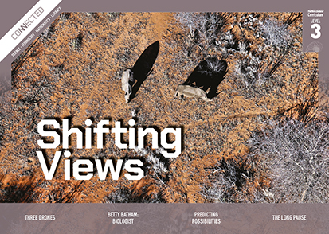
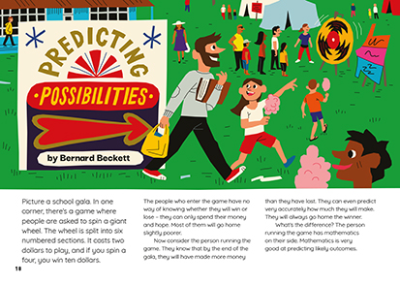

The Literacy Learning Progressions: Meeting the Reading and Writing Demands of the Curriculum describe the literacy-related knowledge, skills, and attitudes that students need to draw on to meet the demands of the curriculum.
The Learning Progression Frameworks (LPF) describe significant signposts in reading and writing as students develop and apply their literacy knowledge and skills with increasing expertise from school entry to the end of year 10.

Overview
This article uses real-world examples to show how mathematics can be used to predict the possible outcomes of a range of human and environmental activities. It describes how mathematical models are created by defining and measuring key variables, designing an equation that shows how the variables interact, and using the equation to make predictions.
A Google Slides version of this article is available at www.connected.tki.org.nz
Curriculum contexts

MATHEMATICS and STATISTICS: Statistics: Probability  Level 3 – Students will investigate simple situations that involve elements of chance by comparing experimental results with expectations from models of all the outcomes, acknowledging that samples vary.  MATHEMATICS and STATISTICS: Statistics: Statistical literacy  Level 3 – Students will evaluate the effectiveness of different displays in representing the findings of a statistical investigation or probability activity undertaken by others. | Key mathematics ideas  - Probability is the chance that something will happen.  - Probability can be calculated.  - Mathematics can be used to predict and understand social and health issues, and suggest possible solutions.
ENGLISH: Reading  Level 3 – Ideas: Students will show a developing understanding of ideas within, across, and beyond texts. | Indicators:  - uses their personal experience and world and literacy knowledge confidently to make meaning from texts  - makes meaning of increasingly complex texts by identifying main and subsidiary ideas in them  - starts to make connections by thinking about underlying ideas in and between texts  - recognises that there may be more than one reading available within a text  - makes and supports inferences from texts with increasing independence.

The New Zealand Curriculum

Meeting the literacy challenges

The main literacy demands of this text lie in the descriptions and presentation of abstract ideas and information, with the focus on algebra. However, the article attempts to make the concepts about prediction and mathematical modelling concrete by applying them to practical, real-world examples. Each section walks the reader through the process of defining the key variables, creating an equation to describe their relationship, and using the information to make predictions. The conclusion reinforces that the process is the same each time.  The text includes a detailed mathematics formula as an example of how variables can be turned into an equation. This is illustrated in a diagram, as are the Ewing theory and the concept of herd immunity.  Throughout, the writer directly addresses the reader with questions and instructions that help connect the written explanations to the visual elements. The chatty, colloquial tone is reassuring, and the examples, while requiring some background knowledge, are from familiar contexts. | The instructional strategies below support students to meet the literacy challenges of this text. For each strategy, there are links to the relevant aspect of The Learning Progression Frameworks (Reading). The signposts on each of these aspects provide detailed illustrations on what to notice as your students develop their literacy knowledge and skills for different purposes in different curriculum areas.  The text includes terms from the language of statistics, as well as topic-specific words related to the three examples. Key concepts are introduced in the text and diagrams and are used repeatedly to build understanding.  The following strategies will support students to understand, respond to, and think critically about the information and ideas.  You may wish to use shared or guided reading, or a mixture of both approaches, depending on your students’ reading expertise and the background knowledge they bring to the text.  After reading the text, support students to explore the activities outlined in the following pages.

INSTRUCTIONAL STRATEGIES

Dealing with abstract ideas  [LPF Reading: Making meaning of text: reading critically]  Share the title and provide a brief overview of the text. Have the students preview page 18. DISCUSS their responses to the ideas on this page.  How can the person running the game know they will make a profit … and even how much?  Tell the students to read on to the bottom of page 20 to find out how mathematics can be used to make predictions. Check that they have understood that there are three steps to creating a mathematical model that can be used to predict the possible outcomes.  - Find and measure the key variables.  - Design an equation that best describes the observed relationship.  - Use the equation to make predictions about future events.  PROMPT the students to look closely at the equation on page 20, making connections between the information in the running text, the information in the visual text, and the equation. Point out the cohesive devices in the running text, such as “next”, “if it is likely”, “then”, “this will”, “this means”. Show them how these devices help them track and connect the key ideas and information in the explanation. Help them to notice that the images run on from the text and that a built-in key runs below them. If necessary, EXPLAIN that algebra uses letters (like x or y) or other symbols in place of values and works with them using special rules. | ASK QUESTIONS to help the students understand the reasoning for this model.  This diagram doesn’t have a heading. What does it show?  There are four variables in spinning the wheel. Where are they shown in the diagram?  What symbols are used to show the different variables? Why are they shown in different colours?  What is the relationship between the number of players and the cost to play? Where is this shown in the diagram? Where is it shown in the equation? Where is it described in the text?  Why do you have to subtract the number of players multiplied by the odds of winning and the winnings from playing? How is this explained in the text?  Why is the $1,670 rounded up?  Talk through the variables in the picture on page 21.  Where is the player who is making the decision?  What do the arrows indicate?  What are the variables the player has to consider? Why do each of them matter?  PROMPT the students to make connections to their personal experiences with sport to consider the relevance of Skinner’s prediction.  Have a think about Skinner’s prediction. Does it make sense to you?  Do you think it might apply to other sports? Can you give examples?  How do you think we might test your ideas?

Meeting the literacy challenges

Using text structure and features  [LPF Reading: Making sense of text: using knowledge of text structure and features]  Put the students in pairs and assign each pair either the model of a disease outbreak (page 23) or that of herd immunity (page 24). Have them talk through the model in their pairs. Point out the cohesive devices on page 23, “When”, “First”, “then”, which help the reader to connect ideas and follow the process. Also, the description of herd immunity on page 24 uses “if” and “then” to connect causes with their effects. When they are confident that they have understood it, have them explain it to another pair. PROMPT them to use their fingers to trace the spread of disease and identify where it can be stopped.  DISCUSS the conclusion and how it reinforces the main idea. Have the students review the text and identify the three steps to creating one of the mathematical models: spinning the wheel, basketball, how disease works or how immunisation works. | Dealing with topic-specific vocabulary  [LPF Reading: Making sense of text: vocabulary knowledge]  Give the students sticky notes to IDENTIFY the language of mathematics used in the article. DISCUSS what they learnt about these words from reading the text and where they have previously encountered the word. Have them use a graphic organiser such as the one below to explore when they are likely to use these words and how they would use them.  Word:  Definition This word could be used when … An example of the word in a sentence  Note  Immunisation is, of course, a controversial issue. There are people who believe that we are better to build our natural immunity. You may find it useful to familiarise yourself with the Immunisation Guidelines for Early Childhood Services and Primary Schools.

The Learning Progression Frameworks
The Literacy Learning Progressions
Effective Literacy Practice: Years 5–8

Illustrating the key ideas

Probability can be calculated. | 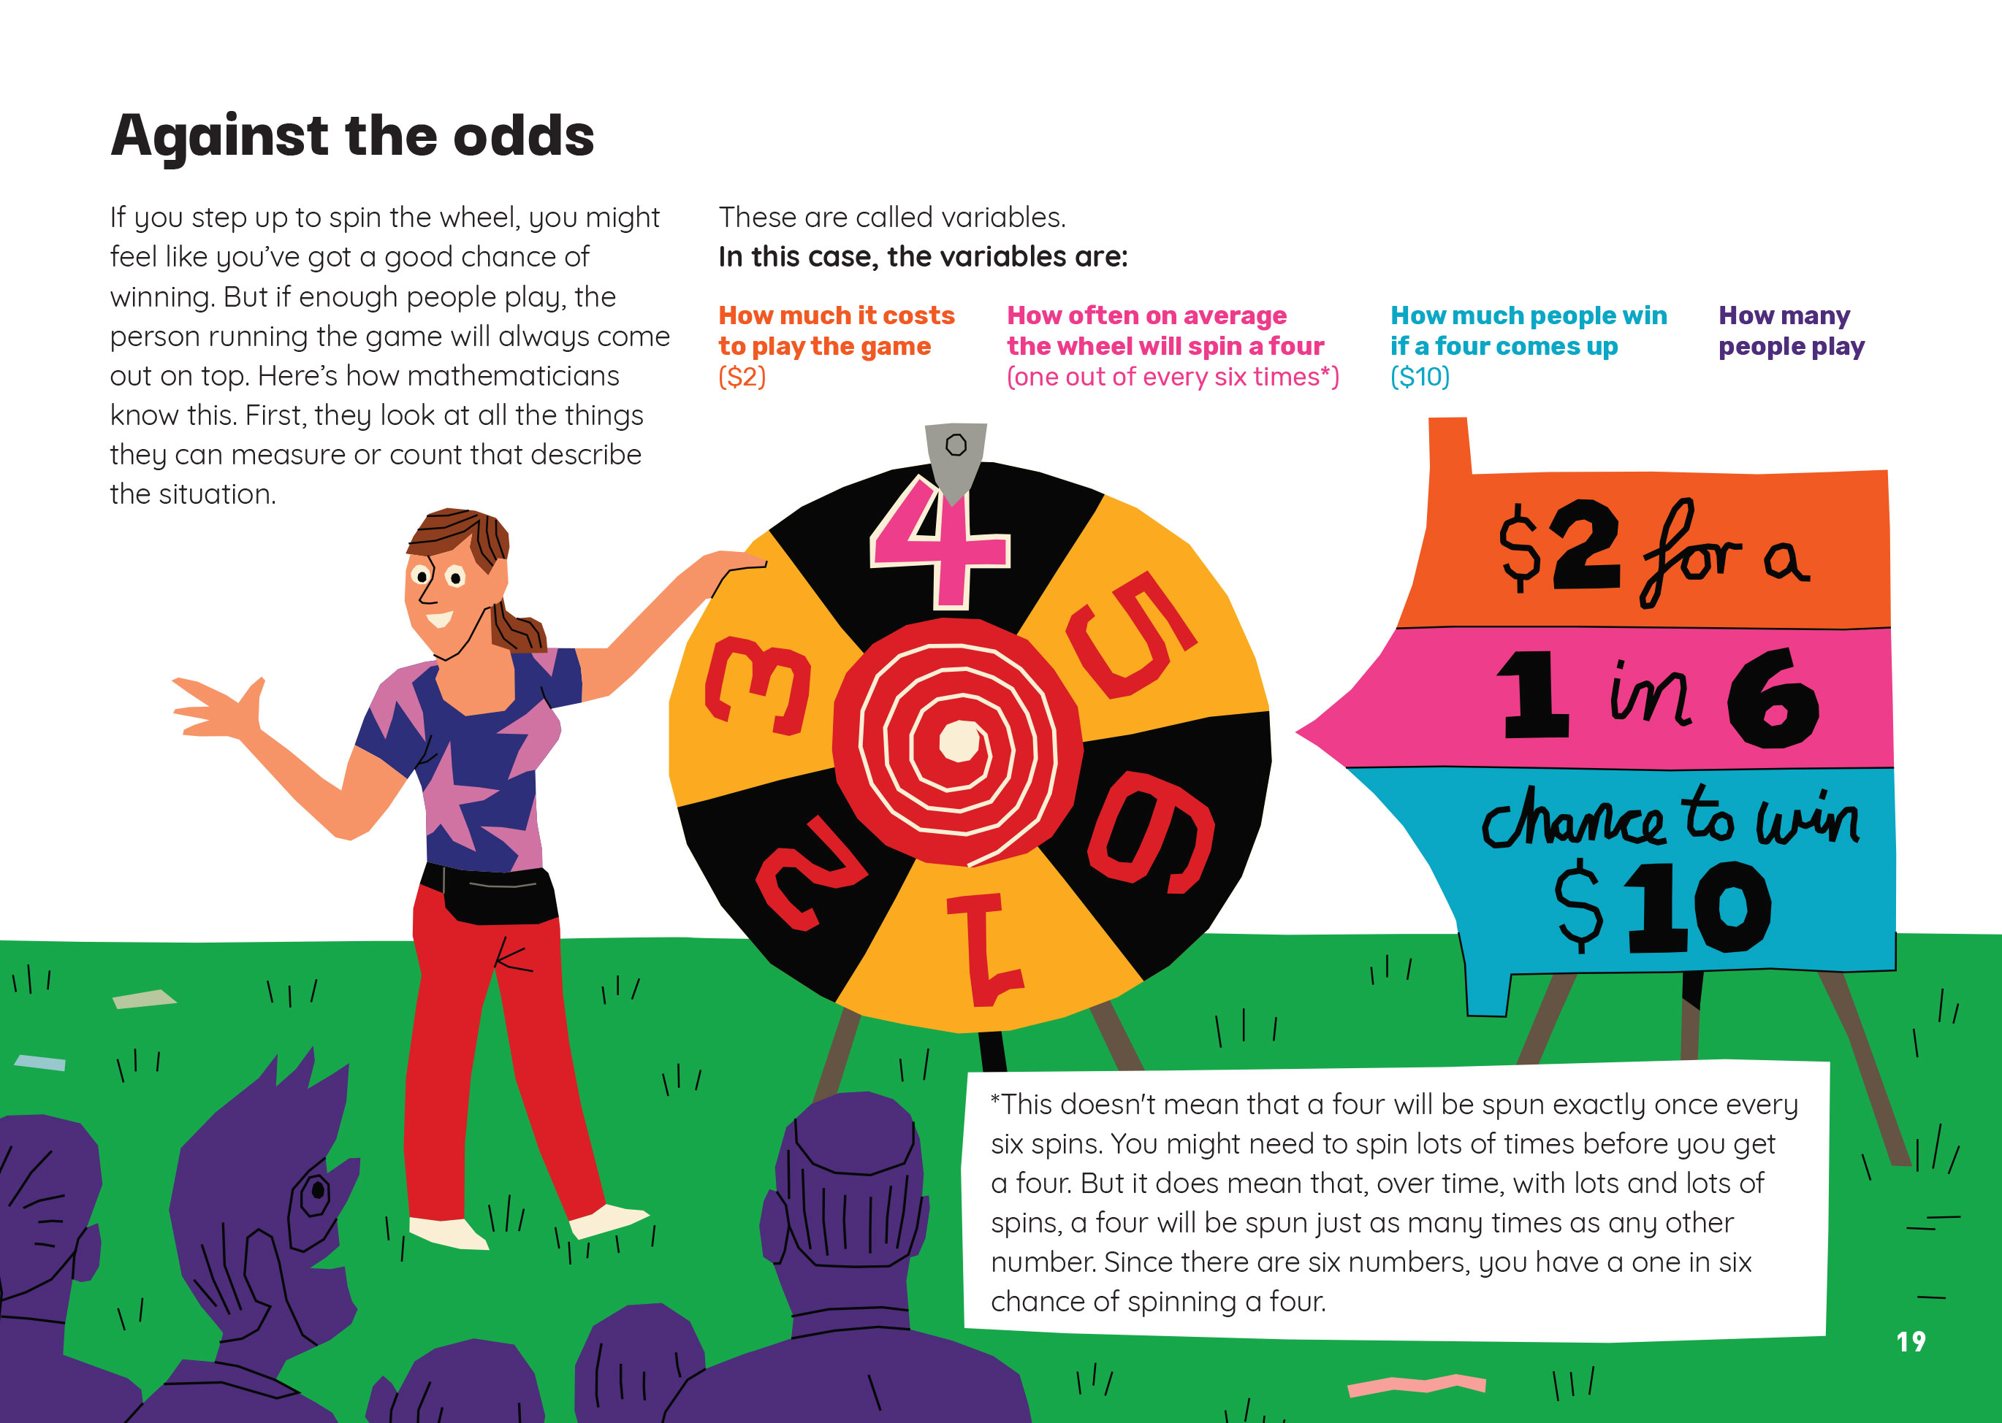  Mathematics can be used to predict and suggest possible outcomes.
 | Probability is the chance that something will happen.

Learning activities – Exploring the
mathematics and statistics
The following activities and suggestions are designed as a guide for supporting students to explore and extend their content knowledge across the learning areas. Adapt these activities to support your students’ interests and learning needs.

Activity 1 – Probably … maybe  Check that everybody understands the equation on page 20. When everyone is confident, have the students try the equation with different numbers (that is, with changes to the number of players, cost to play, odds, or prize money). As the students become more confident, they could experiment with changes to the variables that would increase the profit.  Extending the learning  The Figure It Out activities listed below could be used to further develop the students’ understandings about probability and the power of mathematics for predicting the future. They could also do the following:  - “Totally Random?” from Connected 2016 introduces students to the mathematical concepts of randomness, patterns, and fairness and their application to everyday lives. Students learn that some outcomes allow us to make predictions whereas others are “random”. The TSMs suggest games and activities for deepening and extending these understandings.  - In the “Fortune Teller” activity from the Raspberry Pi website, students make a “fortune teller” that works like a magic 8-ball, giving the user answers to questions they ask their micro:bit. In “Rock, Paper, Scissors”, students use variables and conditional statements to make and play a game.  - Scootle offers digital learning objects for learning about probability, including a series that involves building and using digital coloured spinners similar to spinning the wheel.  Have the students use what they have learned to develop their own models for predicting possible outcomes. For example, students could define and measure variables to predict:  - how many ice creams the local store is likely to sell on a hot day  - how many seedlings are likely to survive being transplanted  - the amount of stored water necessary in a civil defence emergency  - fluctuations in attendance over the course of the school year and how they relate to seasonal change  - likely profits from the school gala  - the likely winners of a game.  The students could test their predictions in real life. As a group, they could then draw conclusions about the possibilities and limitations of mathematical modelling. Remind the students that we always need to check the theory against reality – there may be variables we have overlooked. | Activity 2 – Protecting the herd  Ask the students to share their understandings of immunity and how vaccines work. Have them check their understandings against the explanation in the “Immunity and vaccines explained” YouTube clip.  Use the “What is herd immunity?” animation to clarify how herd immunity works and what happens when herd immunity breaks down. “The Standing Disease” is a game that simulates the outbreak of a disease.  Introduce students to the potential consequences of an epidemic. The School Journal article, “Pandemic: The Deadly Flu of 1918” conveys the horror of the 1918 flu epidemic and the struggle to contain it at a time before vaccinations were available.  Extending the learning  Discuss other ways mathematics could be used to understand social and health issues. Identify examples the students could investigate, either at a national level or within your school or local community. For example, the students could:  - explore data from CensusAtSchool TataurangaKiTeKura about topics such as physical activity, sleep, or screen time, comparing this to a survey of their peers and considering whether there are areas of risk that could be addressed through a communications campaign  - consider the potential impact of a public-health campaign aimed at encouraging people to cover their nose and mouth when they sneeze, staying home when they have a bug, or increasing their intake of fruit and vegetables  - learn about the spread of disease among livestock or through plant species, weighing up the cost of prevention or mitigation against the cost to our economy.

RESOURCE LINKS

Connected and School Journal  “Totally Random?”, Connected 2016, Level 3, Picture This  “Pandemic: The Deadly Flu of 1918”, School Journal, Level 4, June 2018  Figure It Out  Statistics: Level 3 (Revised edition): Dicey Differences: https://nzmaths.co.nz/resource/dicey-differences  Statistics: Levels 3–4 (Revised edition):  - Left to Chance: https://nzmaths.co.nz/resource/left-chance  - Take Five: https://nzmaths.co.nz/resource/take-five  Science Learning Hub  The history of vaccination: https://www.sciencelearn.org.nz/resources/181-the-history-of-vaccination  Vaccines and therapies: https://www.sciencelearn.org.nz/resources/180-vaccines-and-therapies  Immunisation in New Zealand: https://www.sciencelearn.org.nz/resources/182-immunisation-in-new-zealand  YouTube  NOVA, “Immunity and vaccines explained”, PBS: https://www.youtube.com/watch?v=lXMc15dA-vw | Raspberry Pi  Fortune teller: https://projects.raspberrypi.org/en/projects/fortune-teller  Rock, paper, scissors: https://projects.raspberrypi.org/en/projects/rock-paper-scissors  Other sources  The Conversation: Can math predict what you’ll do next? https://theconversation.com/can-math-predict-what-youll-do-next-78892  VaccinesToday: What is herd immunity? https://www.vaccinestoday.eu/stories/what-is-herd-immunity/  NRICH: The standing disease: https://nrich.maths.org/12119  CensusAtSchool TataurangaKiTeKura: https://new.censusatschool.org.nz/  Scootle: Probability: http://www.scootle.edu.au/ec/search?topic=%22Probability%22&sort=relevance  HealthEd: Immunisation Guidelines for Early Childhood Services and Primary Schools: https://www.healthed.govt.nz/resource/immunisation-guidelines-early-childhood-services-and-primary-schools-%E2%80%93-english-version

